Chhay Lay Heng

CS 4141.115

November 3, 2023

Experiment 3 Post-Lab”

Partners: Korbin Schulz and Bennett Quigley

**Part 1. 4-bit Addition using an IC chip such as 74LS283**

* Results of 10 4-bit Additions

|  |  |  |  |  |
| --- | --- | --- | --- | --- |
| Input A | Input B | Cin | Sum | Cout |
| 0000 | 0000 | 0 | 0000 | 0 |
| 0000 | 0001 | 0 | 0001 | 0 |
| 0000 | 0010 | 0 | 0010 | 0 |
| 0000 | 0011 | 0 | 0011 | 0 |
| 0000 | 0100 | 0 | 0100 | 0 |
| 0000 | 0101 | 0 | 0101 | 0 |
| 0000 | 0110 | 0 | 0110 | 0 |
| 0000 | 0111 | 0 | 0111 | 0 |
| 0000 | 1000 | 0 | 1000 | 0 |
| 0000 | 1001 | 0 | 1001 | 0 |

* + Circuit Diagram of the IC chip

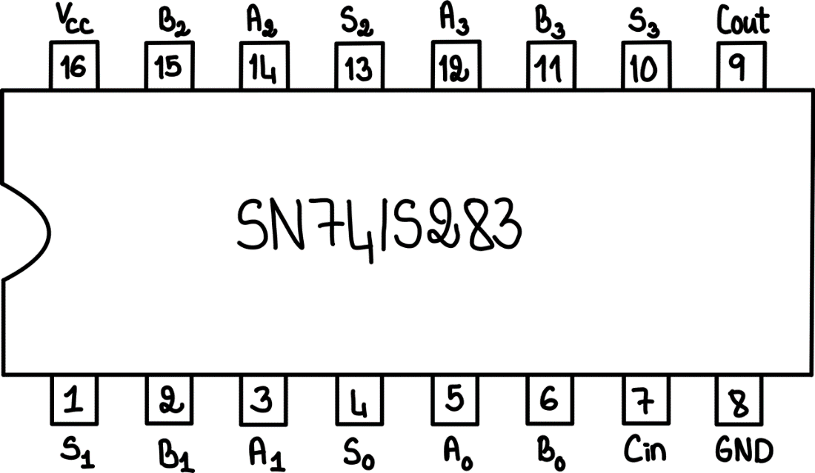

**Part 2. 4-bit Subtraction using an IC chip such as 74LS283**

* Results of 5 2-bit additions, and 5 2-bit subtractions

|  |  |  |  |  |  |
| --- | --- | --- | --- | --- | --- |
| Input A | Input B | Cin | Binary Output | Binary Integer | 2’s Compliment Integer |
| 0000 | 0000 | 0 | 0000 | 0 | 0 |
| 0000 | 0001 | 0 | 0001 | 1 | 1 |
| 0001 | 0011 | 1 | 1110 | 14 | -2 |
| 0001 | 0010 | 1 | 1111 | 15 | -1 |
| 0011 | 0101 | 1 | 1000 | 8 | 8 |
| 0011 | 0010 | 0 | 0101 | 5 | 5 |
| 0101 | 0111 | 0 | 1100 | 12 | -4 |
| 0101 | 1100 | 1 | 1001 | 9 | -7 |
| 1100 | 1010 | 1 | 0010 | 2 | 2 |
| 1100 | 1100 | 0 | 0000 | 0 | 0 |

* Circuit Diagram of the 2-bit Adder/Subtractor

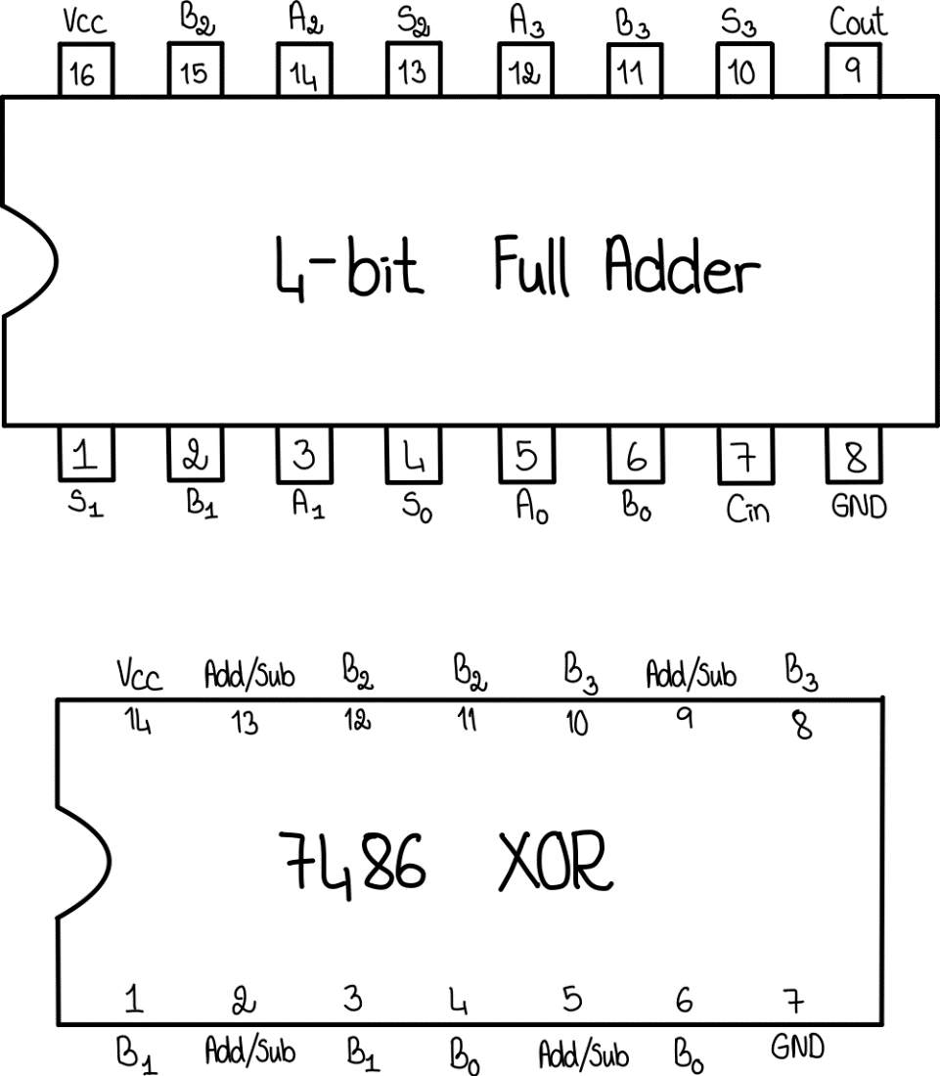

**Part 3. Construct a Binary Coded Decimal (BCD) adder using the 4-bit binary full adders.**

* + Truth Table of 0 through 19 for the BCD Adder

|  |  |  |
| --- | --- | --- |
| Decimal | Binary | Binary Coded Decimal (BCD) |
| 0 | 0000_0000 | 0000_0000 |
| 1 | 0000_0001 | 0000_0001 |
| 2 | 0000_0010 | 0000_0010 |
| 3 | 0000_0011 | 0000_0011 |
| 4 | 0000_0100 | 0000_0100 |
| 5 | 0000_0101 | 0000_0101 |
| 6 | 0000_0110 | 0000_0110 |
| 7 | 0000_0111 | 0000_0111 |
| 8 | 0000_1000 | 0000_1000 |
| 9 | 0000_1001 | 0000_1001 |
| 10 | 0000_1010 | 0001_0000 |
| 11 | 0000_1011 | 0001_0001 |
| 12 | 0000_1100 | 0001_0010 |
| 13 | 0000_1101 | 0001_0011 |
| 14 | 0000_1110 | 0001_0100 |
| 15 | 0000_1111 | 0001_0101 |
| 16 | 0001_0000 | 0001_0110 |
| 17 | 0001_0001 | 0001_0111 |
| 18 | 0001_0010 | 0001_1000 |
| 19 | 0001_0011 | 0001_1001 |

* + Circuit Diagram of the BCD Adder

